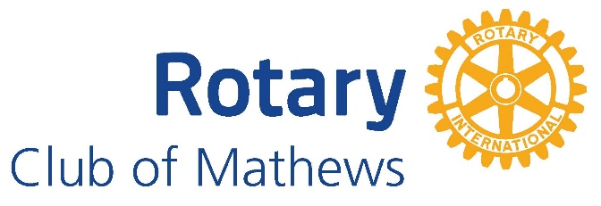
Community Service Project Application Form
*Today’s Date:
*Name of Organization:
*Non-Profit Organization: YES or NO
*Contact Person:
*Organization mailing address:
*Email Address/Phone Number:
*Funding Amount Requested: (Max: $1,500.00)
*Is there a labor component to this project that the Rotary club can do: Yes or No
*Would you be willing to come to our Rotary meeting to speak about your organization, why you need the support, and how you plan to use them? YES or NO
- How will the funds received be used, please be specific? __________________________________________________________________________________________________________________________________________________________________________________________________________________________________________
- What will the labor component be comprised of, please be specific? __________________________________________________________________________________________________________________________________________________________________________________________________________________________________________

- Who are the beneficiaries of the funds? Approximately how many people will benefit from the funds? __________________________________________________________________________________________________________________________________________________________________________________________________________________________________________
*Note: Contribution requests are a one-time donation within our fiscal year. (July 1 -June 30)
Please return the completed form to:
The Rotary Club of Mathews Or by email to MathewsVARotary@gmail.com
Attn. Community Service Project
P.O. Box 282
Mathews, VA 23109

